Module 9 Assignment: Working with Raw SQL in pgAdmin
Eugene Amparbeng
- Screenshot #1: Create Tables
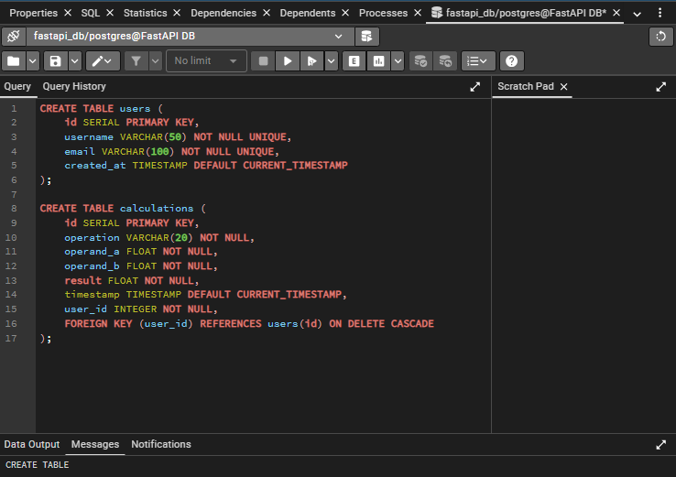

- Screenshot #2: Insert Records
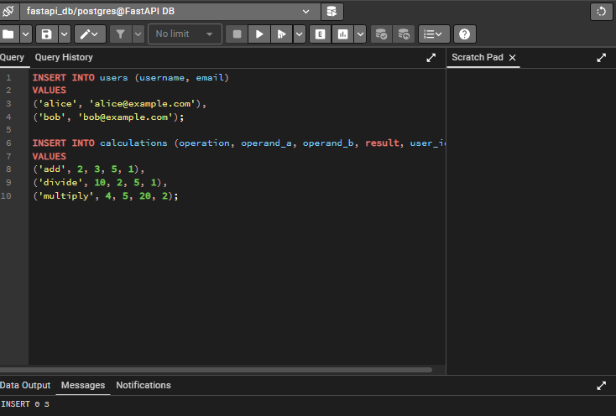

- Screenshot #3: Select Users
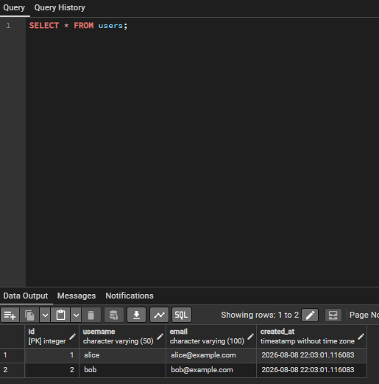

- Screenshot #4: Select Calculations
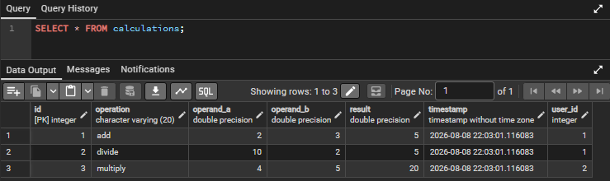

- Screenshot #5: Joined Result Set
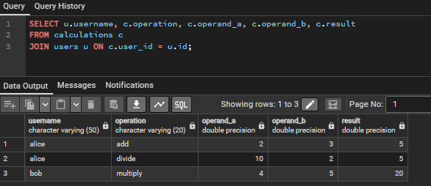

- Screenshot #6: Update Record
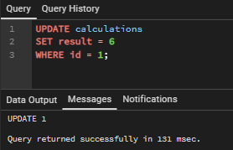

- Screenshot #7: Delete Record
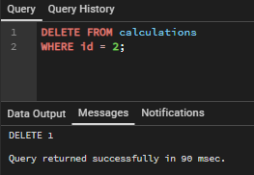

- Brief Reflection:
Working with raw SQL in pgAdmin gave me hands-on experience with database operations. I learned how to define table schemas with proper constraints, insert and query data, and perform updates and deletions. The Docker Compose setup made it easy to run PostgreSQL and pgAdmin without installing them locally. I now understand the importance of foreign keys for maintaining referential integrity and how SQL joins combine data from multiple tables.

